User, Group and Role Management

Introduction
In this tutorial, we are going to try out the User, Group and Role Management in WSO2 Identity Server. This topic involves:
- managing users, groups, and roles.
- managing permissions associated with roles and groups.
- assigning users to groups and roles.
These user management tasks can be performed in various ways, including using the Console app, using APIs and using My Account.
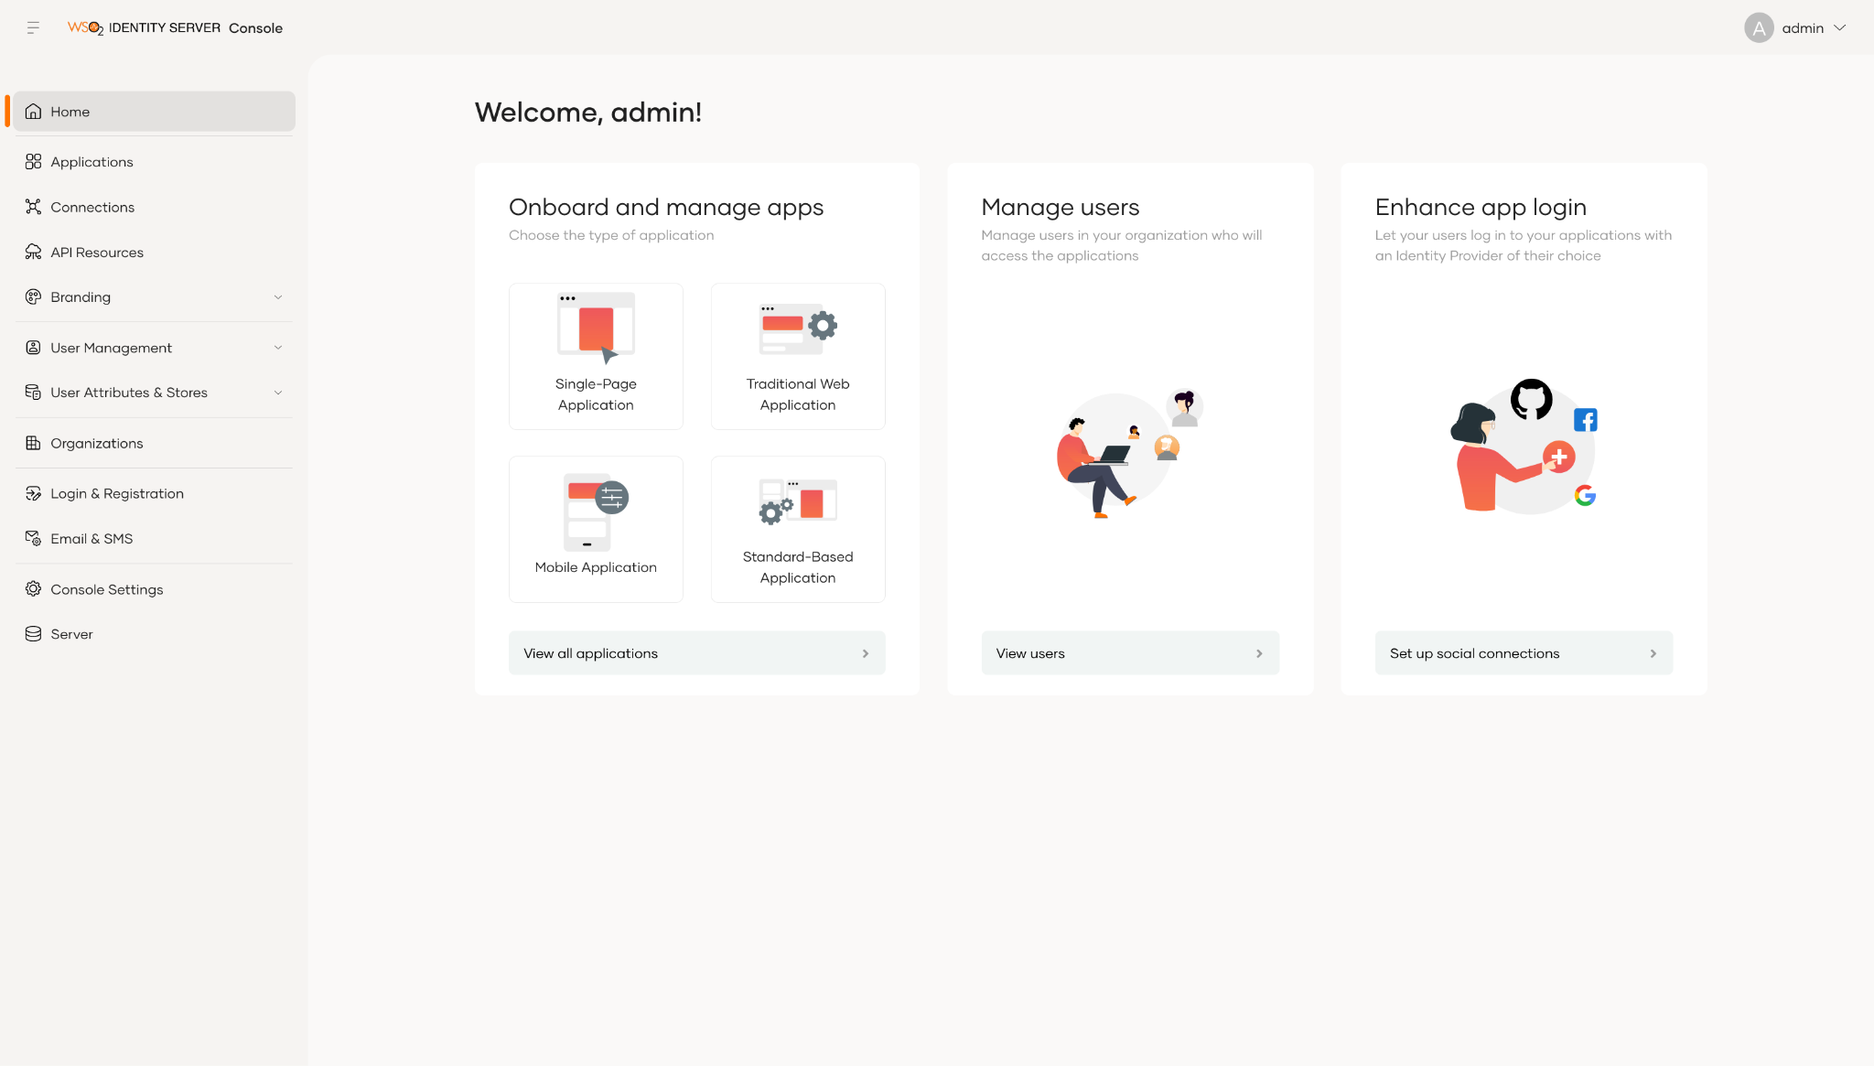

Lab 01: User Management via Console
Let’s create a user and assign the user to a group. And then create a role and assign the role to the group. This way, users will have permissions associated with the roles assigned to the group.

Access Console
To access the Wso2 Identity Server Console, follow these steps:
- Download the latest version of WSO2 Identity Server from the web site .
- Please verify that all the system requirements are satisfied.
  - Java version should be 21 or 25.
- Navigate to <IS_HOME>/bin and start the server by executing either of the following,
./wso2server.sh (Ubuntu , Mac) or ./wso2server.bat run (Windows)
- Log in to the Console App (https://localhost:9443/console), and enter admin as both the username and the password.
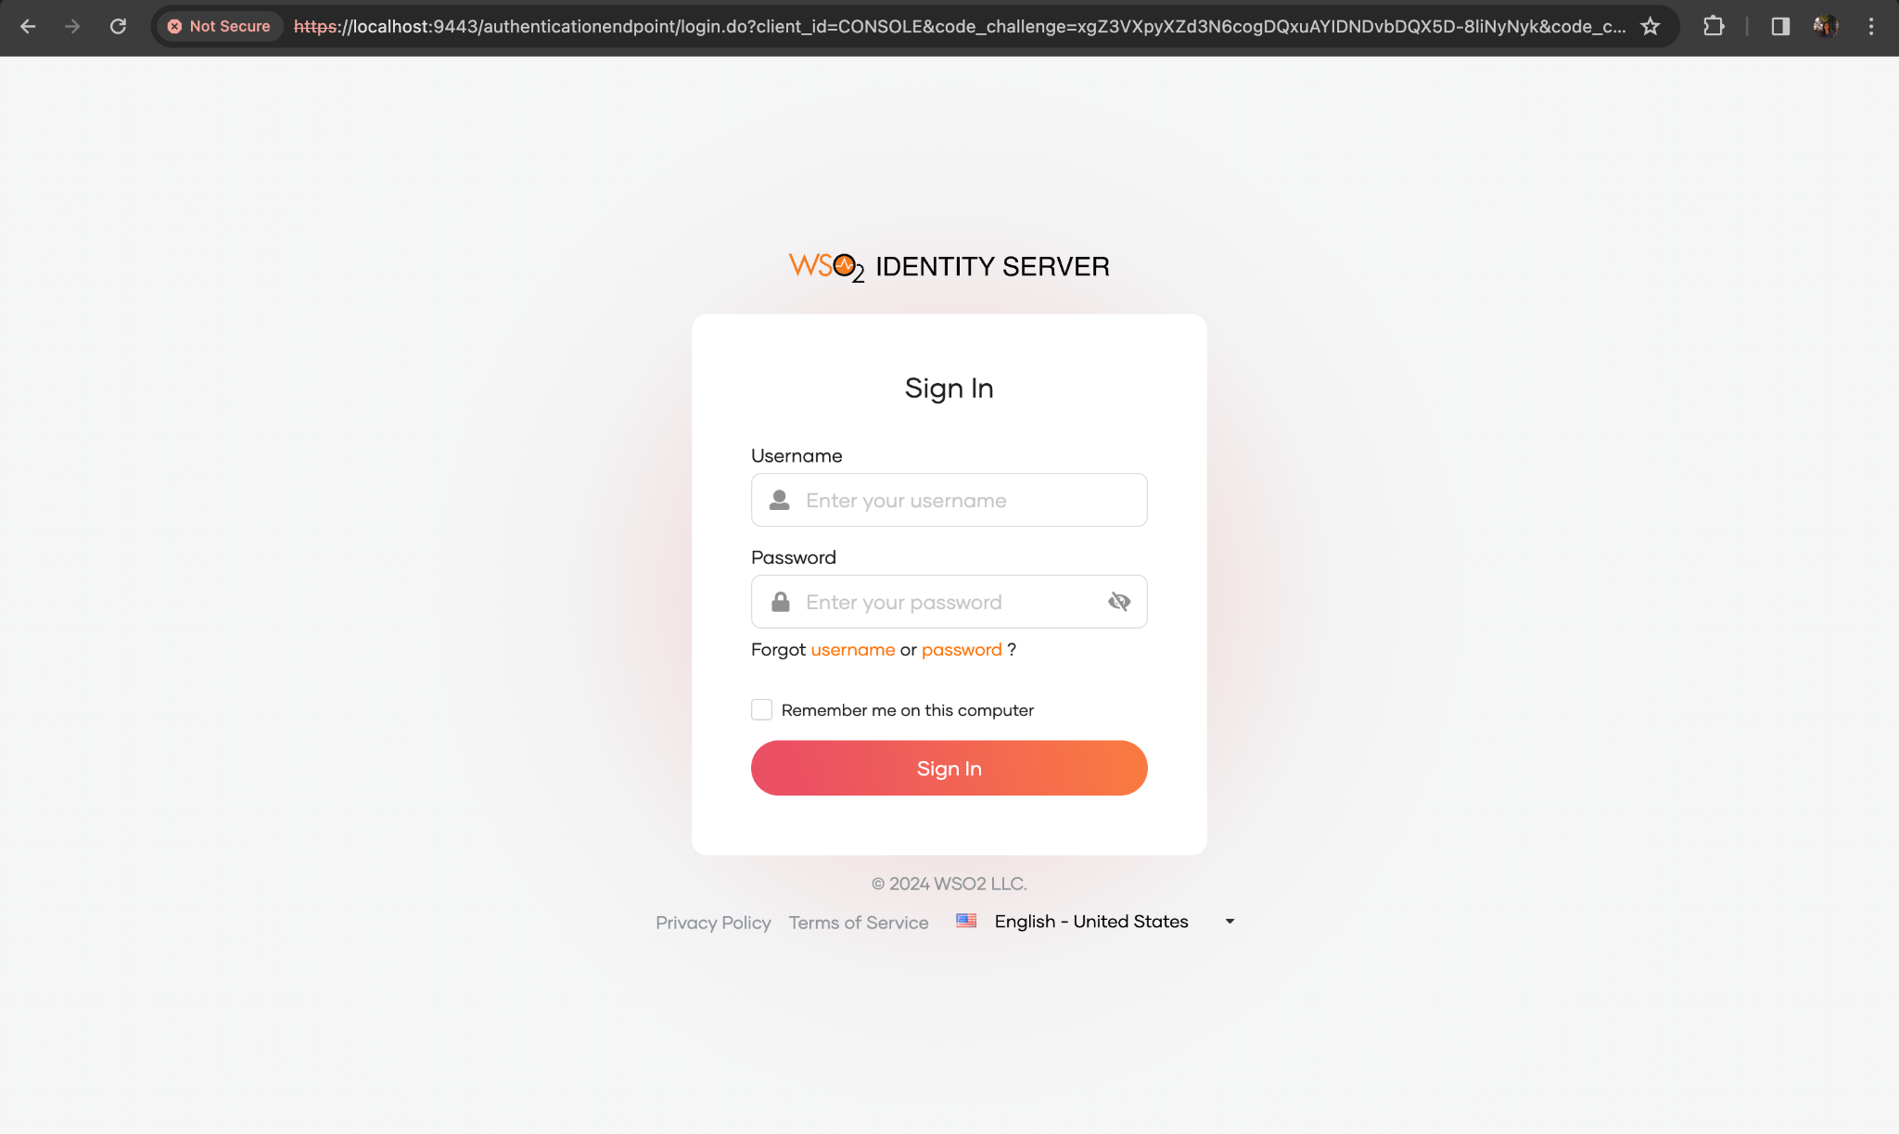

Add New Users

To add a new user, follow these steps:
- Expand the User Management menu item, click on Users.
- On the Users page, click Add User and select Single User from the dropdown.
- In the opened up wizard,
  - Keep Primary as the user store.
  - Add the below configuration to the respective fields.
    - Username: john
    - Email: john@wso2.com
    - First Name: John
    - Last Name: Doe
  - When you scroll down a bit, you will see 2 options as the method to set the user password. For the simplicity of the guide, select Set a password for the user option.
    - When Invite the user to set their own password option is selected, an email will be sent to the configured email address and the user will have to go to the link to get to the password setting page. There, the user can add the preferred password.
- As we selected Set a password for the user option add the below password as the user password.
  - Password: John@1234
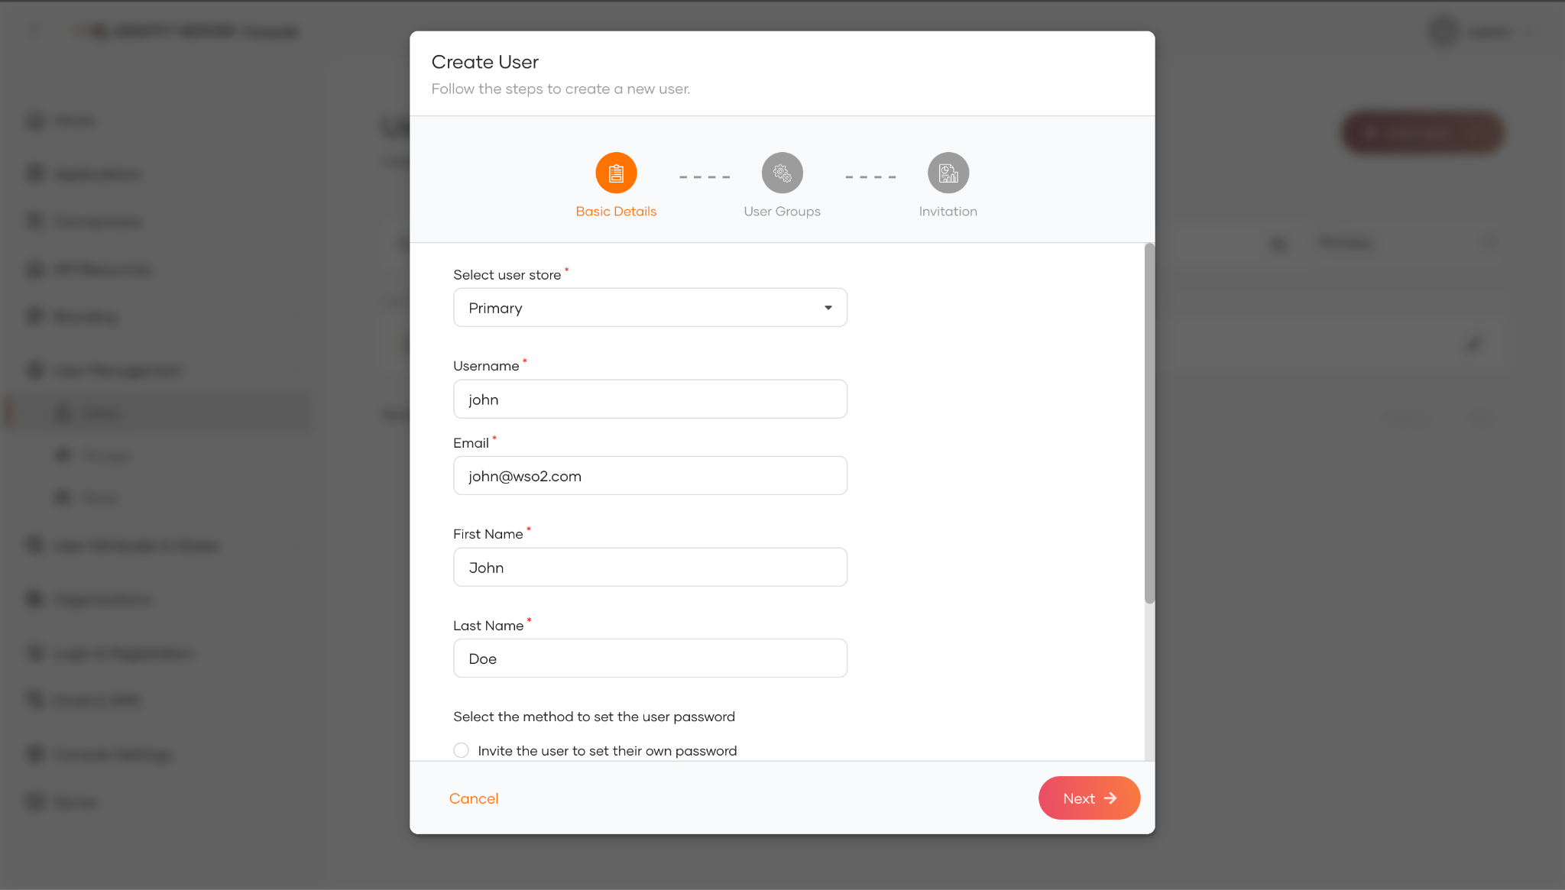
- Click Next.
- As we have not added any groups yet, skip group selection and Click Save & Continue.
- Click Close.

Add New Groups
Group is a collection of users who are managed as a single unit within the organization to streamline assigning permissions and roles.

To add a new groups, follow these steps:
- Expand the User Management menu item, click Groups.
- On the Groups page, click New Group.
- Enter Managers as the group name.
- From the list of users, select john as a member of the Managers group.
- Click Next.
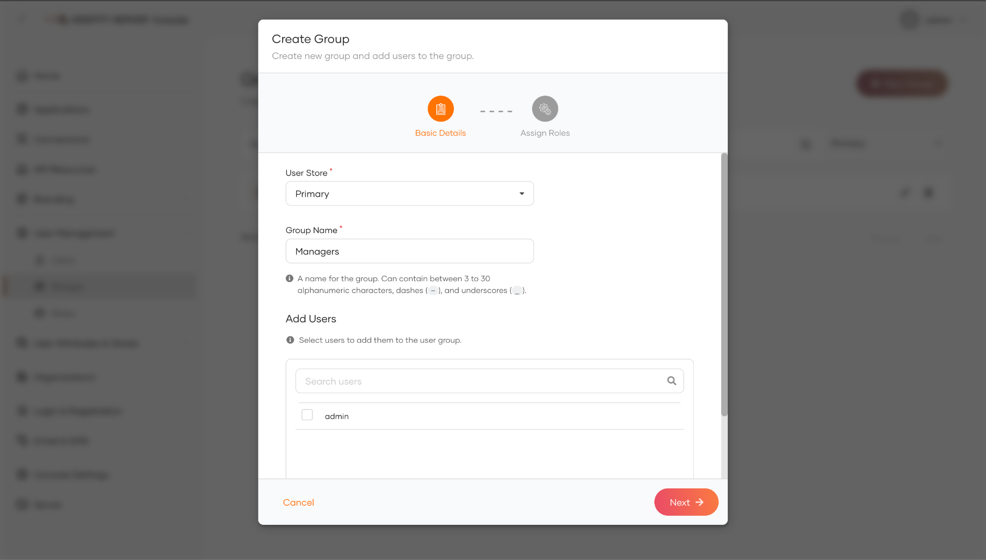
- As we have not created any roles yet, skip role selection and Click Finish.

Add New User Role
Role represents a set of permissions and responsibilities assigned to a user or group of users within an application, or organization.

Organization Role
Organization roles are defined in the organization level and can be used in the application level when multiple applications use the same access privileges.

To add a new user role, follow these steps:
- Expand the User Management menu item, click Roles.
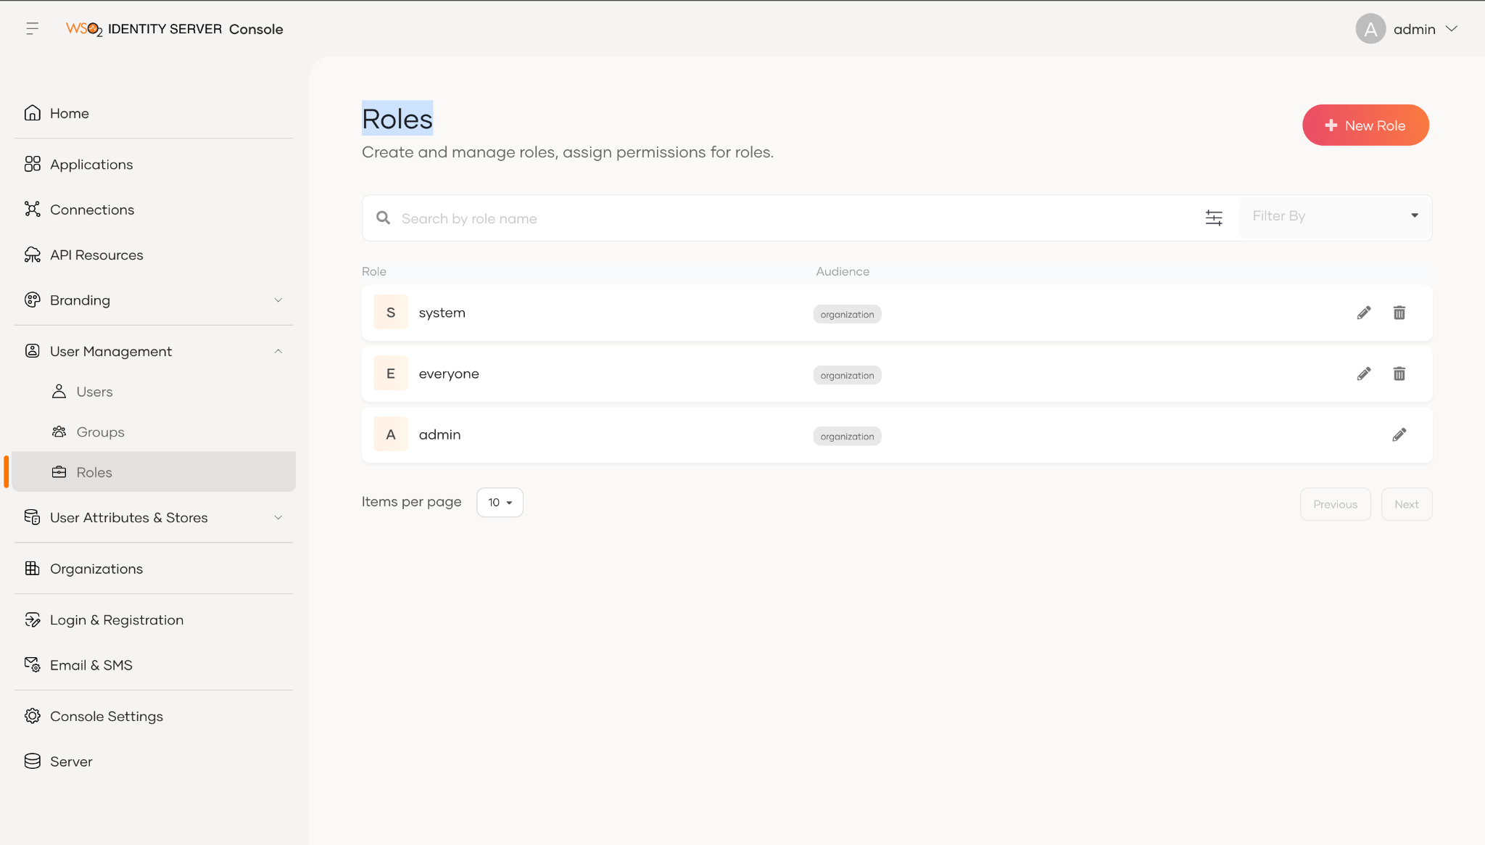
- On the Roles page, click New Role.
- Enter Manager as the role name.
- Select Organization as the role audience.
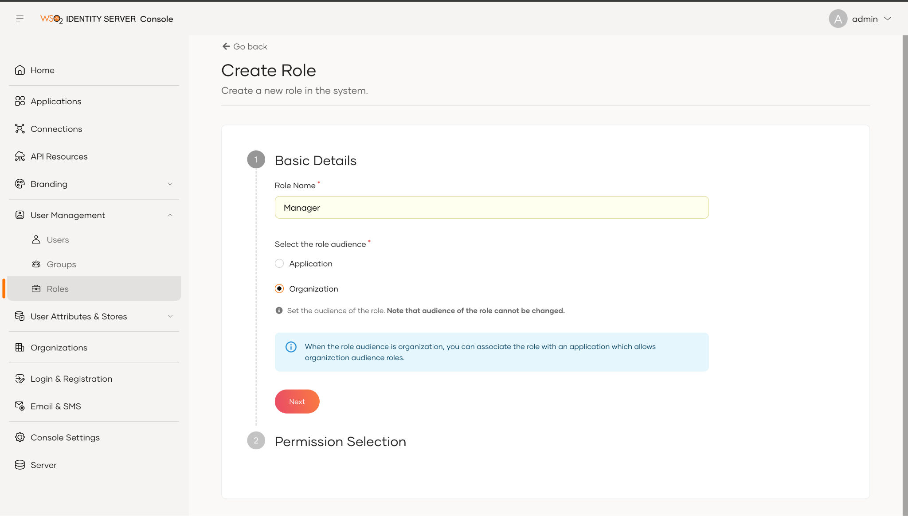
- Click Next to goto the Permission Selection section.
- Choose relevant scope from the drop down given. (To maintain the simplicity of this section, let's skip the step)
- Click Finish.
- On the Role page, goto Groups tab and click on Assign Groups to add groups.
- From the dropdown, select Managers group.
- Click Update.

Application Role
These types of roles are tailored to the specific requirements of an application. Further details about application roles such as usage will be discussed in 12. API Authorization tutorial.

Update Existing User Role

To update the Manager role that you previously added, follow these steps:
- Expand the User Management menu item, click Roles.
- On the Roles page, the Manager role is displayed in the list of roles.
- Click on the Edit button.
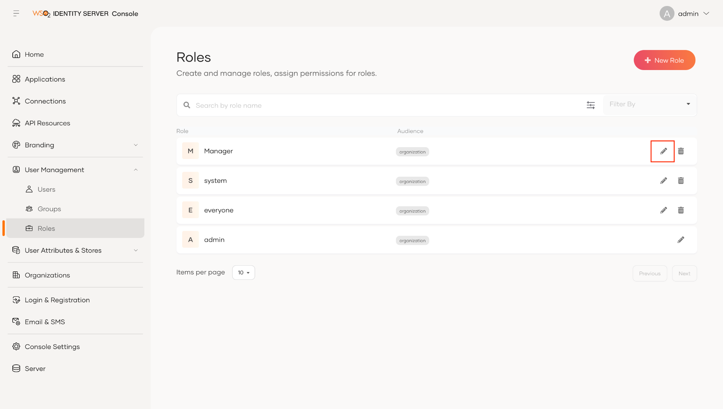
- Enter a new name in the Role name area, and click Update.
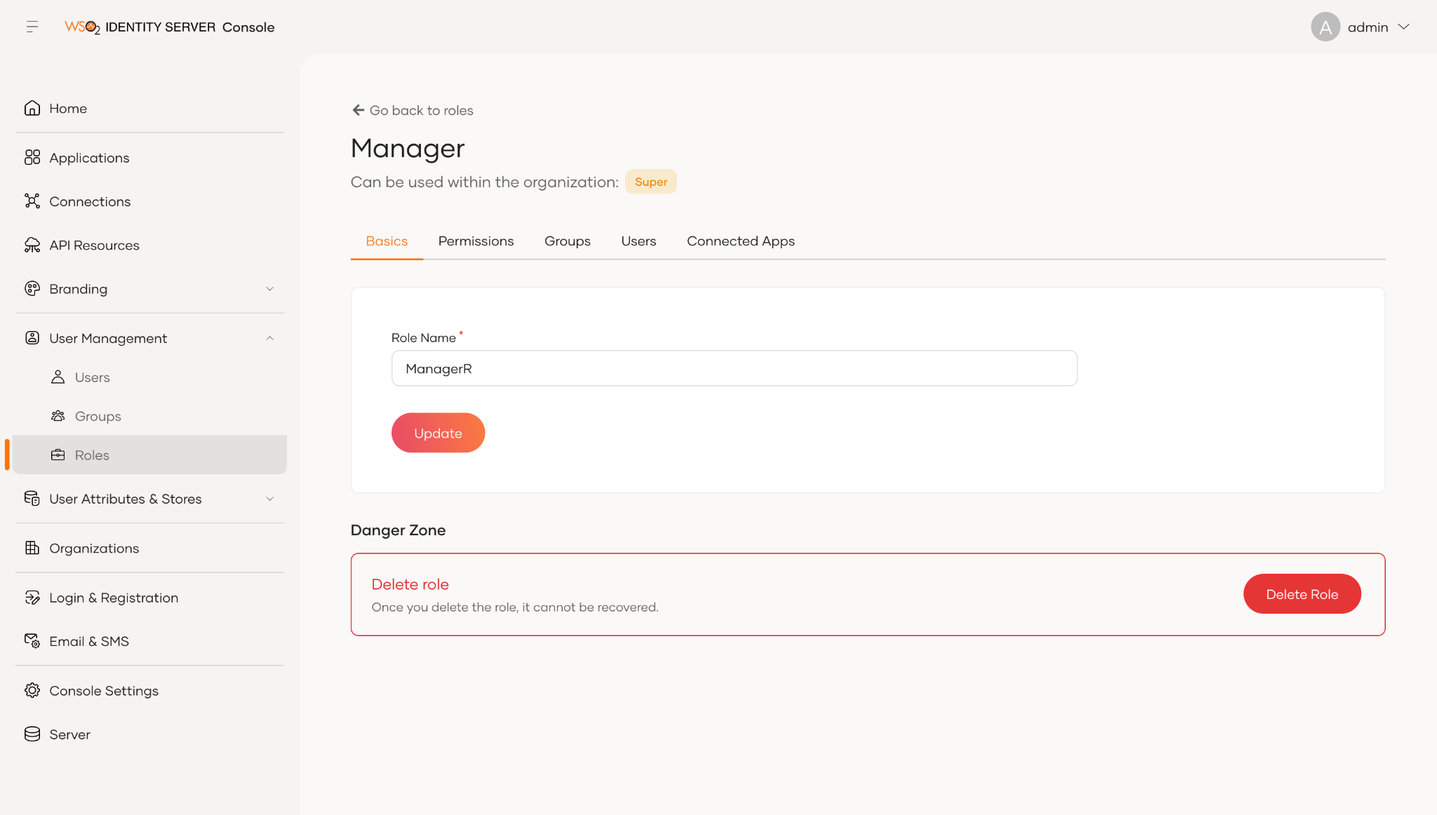

Delete User Roles
To delete a role, follow these steps:
- Expand the User Management menu item, click Roles.
- Click on the bin icon of the relevant role to Delete role.
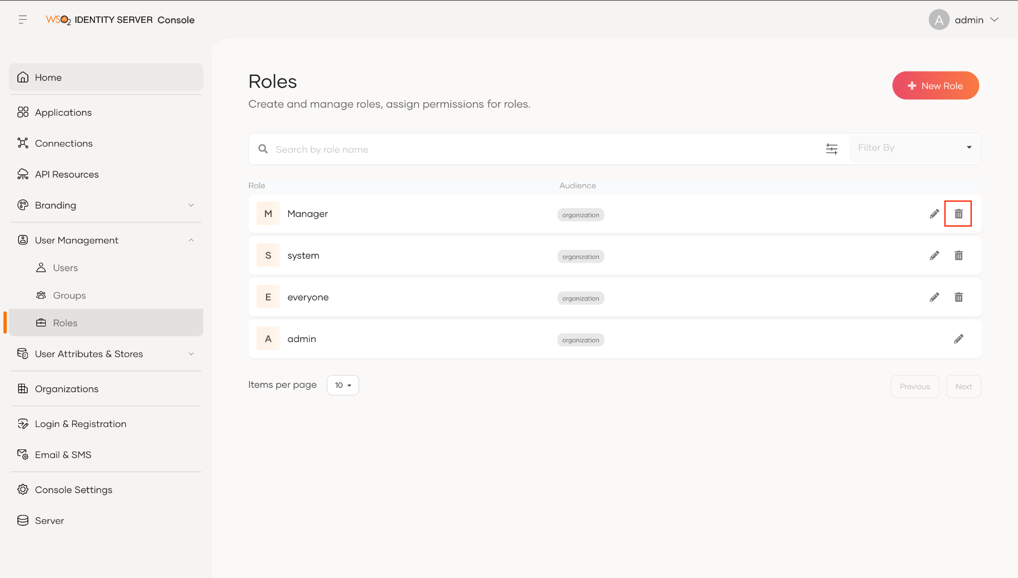

Assign Permissions to a User Role

To assign permissions to a specific user role, follow these steps:
- Expand the User Management menu item, click Roles.
- On the Roles page, click on the Edit button of the Manager role displayed in the list of roles.
- Click on the Permissions tab to add a permission.
- When you expand the drop down of Select API Resource, the available API resources are listed as options. By selecting the API resources you will be giving the role to have access to the selected API resources.
- Select the SCIM2 Roles V1/V2 API under Management APIs as the API resource.
- After selecting an API Resource you need to select the level of permissions(scopes) you want to have for the selected API Resource. ex: view, edit, update, delete
- Select View Role and Create Role as the scope.
- Click Update.

Try It
To verify whether the users, role, and group you defined are correctly updated, follow these steps:
- Expand User Management menu Item and select Groups.
- Select Managers Group.
- Goto the Users tab.
  - You should see john listed as a user.
- Goto the Roles tab.
  - You should see Manager listed as a role.

Lab 02: User Self-Registration via My Account

To learn how a user can self-register via My Account, follow these steps:
- To enable self user registration in your organization, follow these sub-steps:
  - On the WSO2 Identity Server Console, go to Flows > Self Registration.
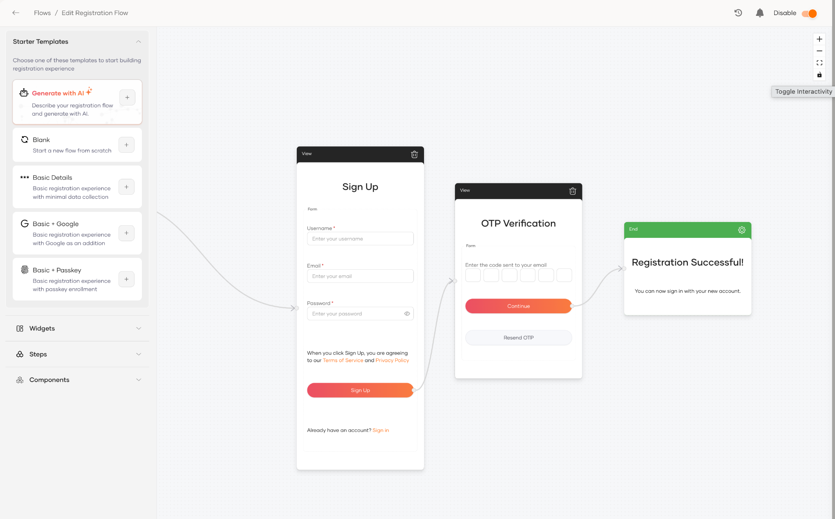
  - Toggle the switch to enable self-registration.
- To send the sign up confirmation email, configure the email server to send emails by following the below steps.
  - Open the deployment.toml file in the <IS_HOME>/repository/conf path.
  - Specify values for the from_address, username, and password parameters in the [output_adapter.email] section as shown in the extract below:
[output_adapter.email]
from_address="<email>"
username="<email>"
password="<password>"
hostname="smtp.gmail.com"
port=587
enable_start_tls=true
enable_authentication=true

(if you are using a gmail account as the sender, create an App password and use that as the password. If your password contains invalid characters such as “>” , “<” and “&”, enter the password as "<![CDATA[xxxx]]>")

  - Restart the WSO2 Identity Server.

Try It

To verify whether you have successfully enabled self-registration, follow these sub-steps:

- Access My Account and click Register.
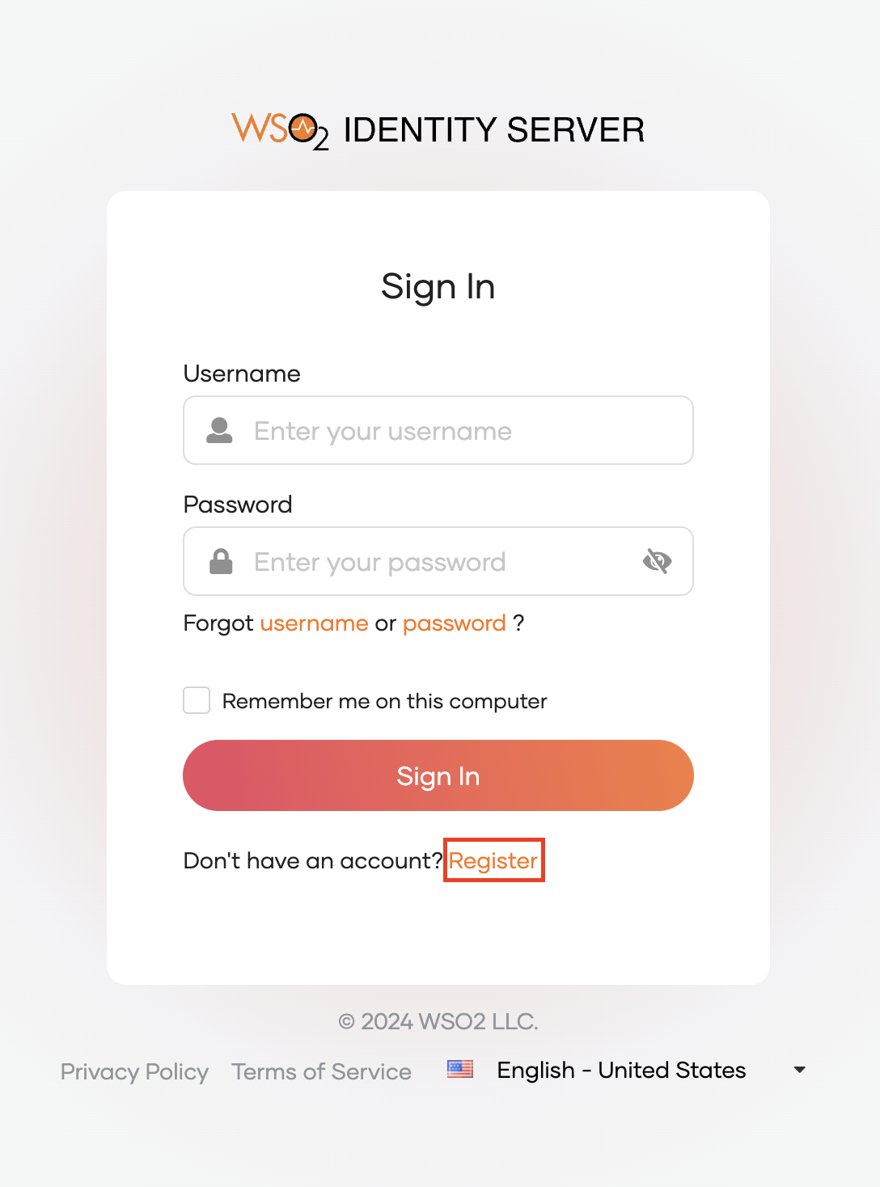
- Specify values for the user account.
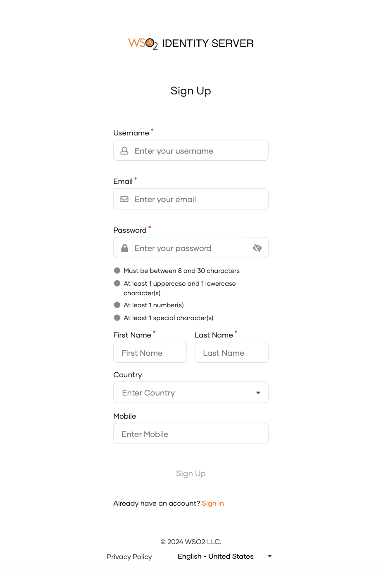
- Click Sign Up.
- Check the inbox of the registered email account. You will receive an email ("Verify your email to complete registration") with a one-time password (OTP). Enter the OTP on the OTP Verification screen and click Continue to complete the registration.
- Go to My account and log in using created users credentials. You should be able to log in.

Lab 03: Setting up a Secondary User Store

In this lab, you will set up the Mysql JDBC Database as a secondary user store in WSO2 IAM and connect a user to it.

Setting Up

To set up the MySQL-based secondary user store, follow these steps:
- First, create a MySQL database and a database user. In the MySQL client (mysql -u root -p), run:
CREATE DATABASE userdb;
CREATE USER 'wso2'@'localhost' IDENTIFIED BY 'Wso2@123';
GRANT ALL ON userdb.* TO 'wso2'@'localhost';
FLUSH PRIVILEGES;
- Create the user store tables by running <IS_HOME>/dbscripts/mysql.sql against the new database. In the same MySQL client, run (use forward slashes in the path, also on Windows):
USE userdb;
SOURCE <IS_HOME>/dbscripts/mysql.sql;
Example on Windows: SOURCE C:/wso2/wso2is-7.3.0/dbscripts/mysql.sql;
- Download MySQL Connector/J (https://dev.mysql.com/downloads/connector/j/, choose Platform Independent) and extract it. The driver is the mysql-connector-j-<version>.jar file in the extracted folder.
- Copy that JAR into the <IS_HOME>/repository/components/lib folder.
- Restart the WSO2 Identity Server.
- On the WSO2 Identity Server Console, go to User Attributes & Stores > User Stores.
- Click New User Store and select the user store type.
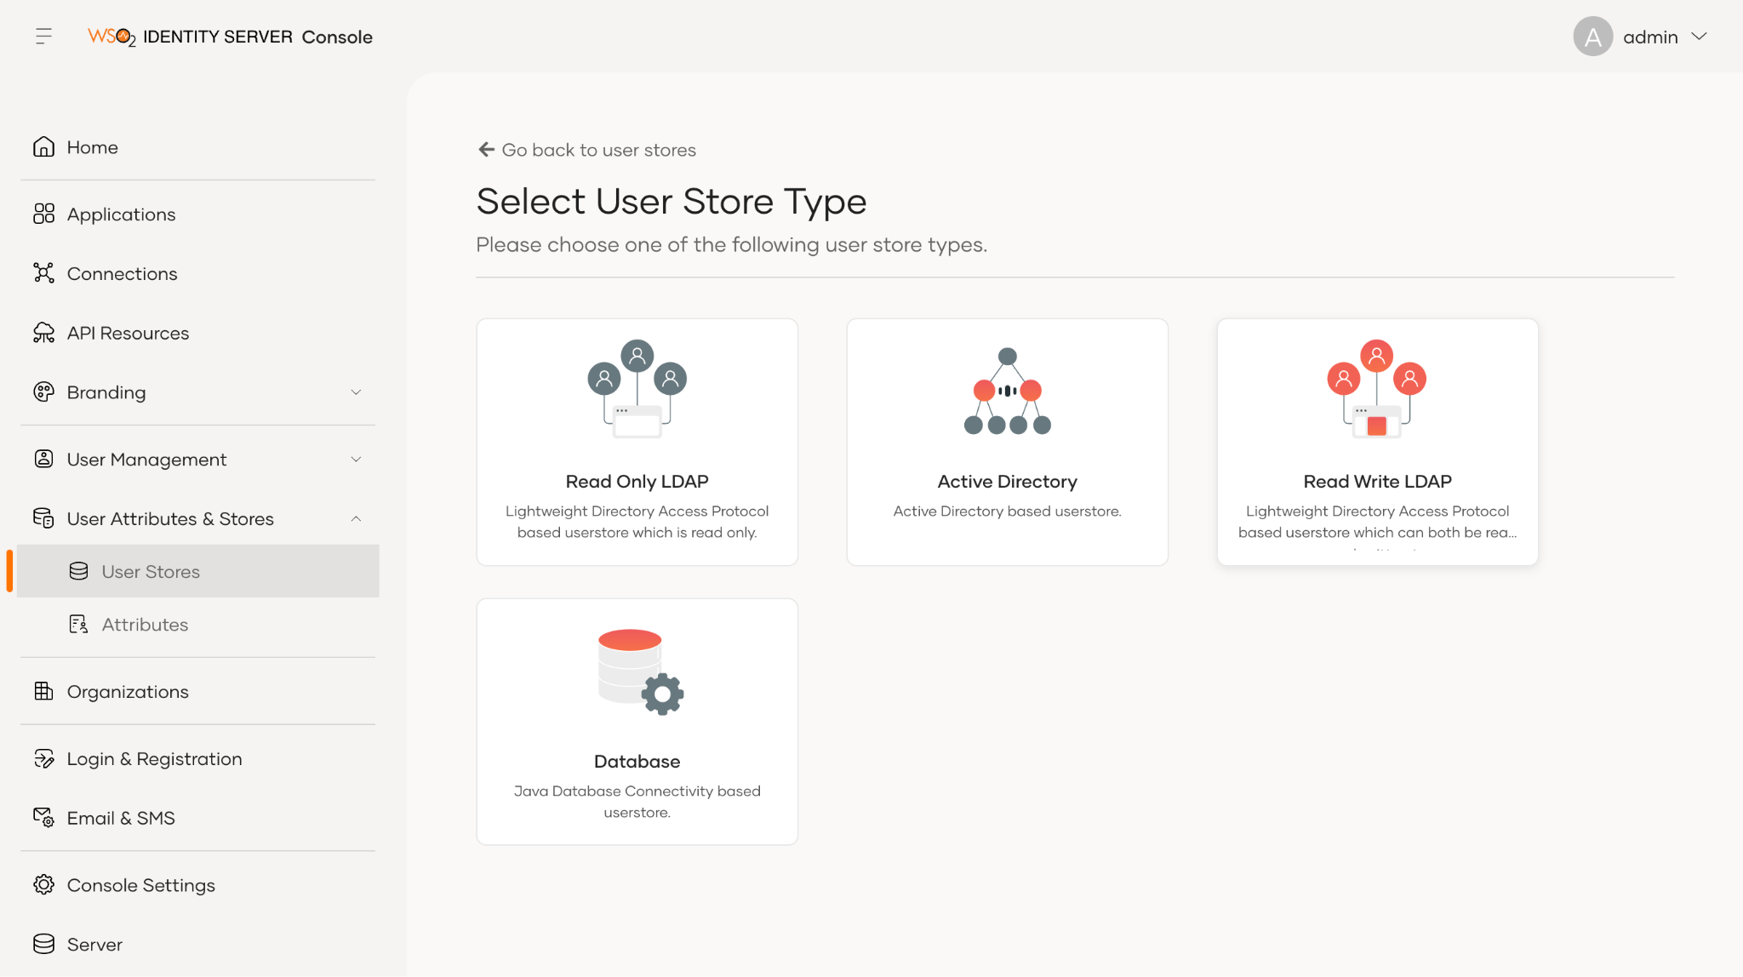
- Select Database as the option.
- Enter the below mentioned values for the mandatory fields.
  - Name: ABCDEmployees
  - Connection URL: jdbc:mysql://localhost:3306/userdb?useSSL=false&allowPublicKeyRetrieval=true
  - Replace userdb if you named the database differently. Use useSSL=false, not sslMode=DISABLED: older Connector/J versions ignore sslMode and still try SSL, so the connection fails.
  - Username: wso2 (the database user you created)
  - Connection Password: Wso2@123
  - Driver Name: com.mysql.cj.jdbc.Driver
- Click Test Connection. When the connection works, the button turns green with a tick.
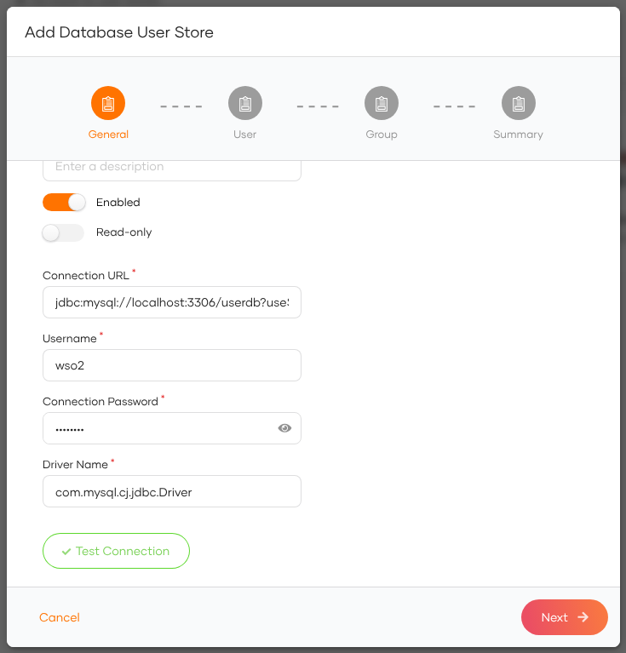
- Click Next.
- Click Next from the User section.
- Click Next from the Group section.
- Click Finish.
- Refresh the page after a few seconds to check the status. If the new user store is successfully added, it will appear in the user stores page.

Let’s try adding a user to the secondary user store
- On the WSO2 Identity Server Console, go to User Management > Users.
- Click on Add User and select Single User.
- In the create user wizard, when you expand the Select user store dropdown, one should be able to see the user store created.
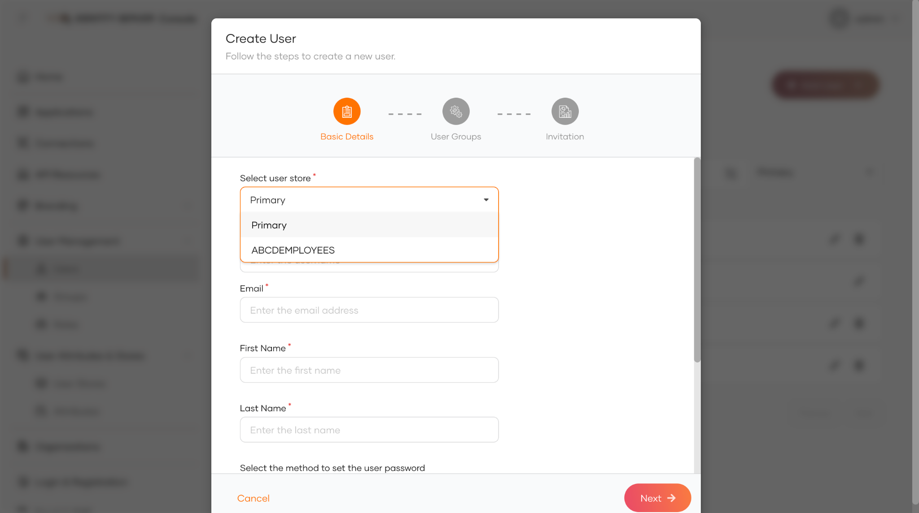
- Select the created ABCDEmployees secondary user store and fill in the relevant information of the user.
- Now a user is added to the secondary user store.
- Query the UM_USER table in the MySQL database (USE userdb; first). You will see that the user is created.
SELECT * FROM UM_USER;

